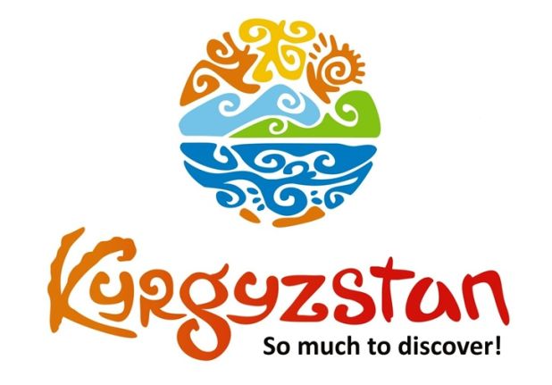**2 weeks cultural tour around Kyrgyzstan**

Country: **Kyrgyzstan**

Period: **June - September**

**Days: 14 / Nights: 13**

Organizing any complexity of tours to Issyk-Kul, Son-Kul, around Kyrgyzstan and Central Asia. We guarantee you high quality of service and individual approach!

Kyrgyzstan is known for its beautiful landscapes with the high mountains and breathtaking alpine lakes. During this tour visitors will see all the highlights that this country has to offer. The views from one destination to another will be absolutely stunning.

There will be a visit to Song-Kul Lake, which is famous for its beautiful location. Moreover, visitors will travel around the Issyk-Kul Lake, the second largest alpine lake in the world!

Furthermore, there will be a tour to the Caravanserai Tash-Rabat, where guests can spend a few nights in yurts and get acquainted with the traditions, handicrafts and national food.

#### [Day 1: Airport - Bishkek (30 km/50 min)](https://concept.kg/en/tours/inbounds/18/#program_collapse_78)

#### 

Upon arrival to airport meet a local guide and transfer to Bishkek city.  
After sightseeing tour of Bishkek - check-in to a hotel (standard check-in time is at/after 14:00pm).  
Free time in the evening.  
Independent lunch and dinner.

Meals: no

#### [Day 2: Bishkek - Chon-Kemin (135 km/3 h)](https://concept.kg/en/tours/inbounds/18/#program_collapse_79)

#### 

Depart to Chon-Kemin Valley. On the way, visit the Burana Tower, a small nearby Museum and open air Balbals (stone figures).  
Upon arrival to the Kalmak-Ashuu village, check in at the Ashuu Eco Lodge. In the afternoon excursion to the Kalmak-Ashuu Gorge on a horse cart. Later, light trekking in the mountains and rest.  
Arrival to the guesthouse and rest.

Possibility to take a walking tour around the village, meet local people and explore the countryside.  
Available activities upon request:  
- horseback riding  
- boorsok show

Meals: breakfast, lunch, dinner

#### [Day 3: Chon-Kemin - Jeti-Oguz (310 km/6 h)](https://concept.kg/en/tours/inbounds/18/#program_collapse_80)

#### 

After the breakfast departure for Jeti-Oguz Valley through the Northern shore of the Issyk-Kul Lake.  
On the way visit open air Petroglyphs Museum and Rukh-Ordo Cultural Complex in Cholpon-Ata town.  
Upon arrival to Karakol, short sightseeing tour. Afterwards, visit One village – One product local souvenir shop, where food and wool products are made by local women.  
Arrival to Jeti-Oguz Valley, accommodation at the yurt camp in Kok-Jayik Jailoo (summer pasture).

Dinner and overnight at the yurt camp.

Note:Accommodation conditions at yurt camp are very traditional, meaning that person will be able to share toilet outside of the yurt and be able to experience Kyrgyz rural lifestyle firsthand. Single accommodation is not available, 3-6 pax per yurt.

Meals: breakfast, lunch, dinner.

#### [Day 4: Jeti-Oguz - Song-Kul Lake (384 km/7 h)](https://concept.kg/en/tours/inbounds/18/#program_collapse_81)

#### 

Free time in the morning.  
Depart to the Song-Kul Lake through the Southern shore of the Issyk-Kul Lake.  
In the morning visit Altyn-Kol (“Golden Hands”), which is a local shop for felt products run by women.  
Visitors can enjoy totally "Instagram-worthy" views on the way to Song-Kul.   
Continue driving and upon arrival to the Song-Kul Lake, accommodation at yurt camp.

Meals: breakfast, lunch, dinner

#### [Day 5: Song-Kul Lake](https://concept.kg/en/tours/inbounds/18/#program_collapse_82)

Full day rest at the lake and hiking tour to the nearby mountains.

Visitors have a chance to get to know Kyrgyz mountain nomads and their lifestyle. Possibility to watch them milking cows and mares, preparing dairy products from the milk and a national Kyrgyz drink Kymyz, cooking food and taking care of households. Even if the locals do not speak the foreign language, they will do their best to be hospitable and understanding. Overnight at the yurt camp.

Meals: breakfast, lunch, dinner

#### [Day 6: Song-Kul Lake - Tash-Rabat (281 km/5 h)](https://concept.kg/en/tours/inbounds/18/#program_collapse_83)

#### 

Drive to Tash-Rabat. On the way, stop in the town of Naryn for a lunch at a local café.  
The Caravanserai Tash Rabat, the unique monument of the Middle Ages, is located in the valley of Kara-Koyun, 90 km from Naryn and 60 km from the village At-Bashi. The building was constructed of stone and lime and all the materials were assembled in the nearby valley. There are several legends about the origins of the architectural complex Tash-Rabat. The most probable theory is that the monument was built in the 15th century and served as a coaching inn for the merchants. Caravans went along the trade routes from the Chui and Ferghana valleys to Kashgar. The height of the Tash-Rabat building is more than 20 m, and there are a total of 31 rooms creating a labyrinth. On the background of the green meadows of the valley the Caravanserai looks like a powerful and unapproachable fortress.  
Upon arrival to Tash-Rabat, accommodation at the yurt camp with basic conditions.  
Excursion to the complex and walking tour to the surrounding mountains.

Meals: breakfast, lunch, dinner

#### [Day 7: Tash-Rabat – Eki-Naryn – Naryn (135 km/4 h)](https://concept.kg/en/tours/inbounds/18/#program_collapse_84)

#### 

After the breakfast departure to the Eki-Naryn Valley.  
The name of the valley Eki-Naryn when translated from the Kyrgyz means “Two Naryn.” Exactly at this place, large and small tributaries merge into the most powerful Naryn River. A National State Reserve “Salkyn Tor” is formed there, where tall pine forests grow. Additionally, the reserve is inhabited by bears, wild boars, mountain goats and snow leopards. The main goal of establishing this national park is conservation of deers. The amazing virgin beauty of the nature of this region will not leave anyone indifferent.  
Depending on visitors’ choice, they can stay at the Eki-Naryn yurt camp for overnight or drive to Naryn (44km) and stay at a guesthouse there.

Meals: breakfast, lunch-box, dinner

#### [Day 8: Naryn- Kazarman (300 km/8 h)](https://concept.kg/en/tours/inbounds/18/#program_collapse_85)

#### 

This day will be long one, but very rewarding. The landscape is absolutely wild and unspoiled.

Most parts of the roads were constructed during the Soviet times. Visitors will pass from the Northern to the Southern part of the country. Kazarman is a small rustic village. Visitors will stay at a family run guesthouse there.

Meals: breakfast, lunch-box, dinner

#### [Day 9: Kazarman - Osh (270 km/5 h)](https://concept.kg/en/tours/inbounds/18/#program_collapse_86)

Visitors will drive to the second capital of Kyrgyzstan – city of Osh. On the way, there will be a stop in the Uzgen town which is famous for producing special type of rice.

Later, visit the rice market and historical minaret. Visitors can also try the Uzgen plov (dish cooked from meat and rice) from a local café for lunch.

Arrival to Osh, accommodation at a homestay. Free time in the evening.

Meals: breakfast, lunch

#### [Day 10: Osh](https://concept.kg/en/tours/inbounds/18/#program_collapse_87)

Full-day sightseeing excursion in Osh.

Half-day excursion to colorful Osh Bazaar (market), then walk through the Alisher Navoi Park and watch elderly people drinking tea and playing chess.

In the afternoon, climb the Holy Suleiman Mountain and visit its cave museum, Silk Road Museum and Alymbek Datka Complex. Dinner at a local Uzbek family’s house with Uzbek food specialties.

Meals: breakfast, lunch

#### [Day 11: Osh - Arslanbob (215 km/4 h)](https://concept.kg/en/tours/inbounds/18/#program_collapse_88)

#### 

Depart to Arslanbob, which is a popular place for its well-known walnut forest. On the way, stop in Uzgen town to visit the Historical Uzgen Minaret and Mausoleum.

Upon arrival to Arslanbob, accommodation at a local family-run guesthouse with basic conditions. Afternoon excursion to the walnut forest and waterfall.

Meals: breakfast, lunch, dinner

#### [Day 12: Arslanbob - Toktogul (400 km/5 h)](https://concept.kg/en/tours/inbounds/18/#program_collapse_89)

#### 

On the way to Toktogul pass through the Tash-Komur Hydro-Electric Station and the Toktogul reservoir.

In Toktogul accommodation at a friendly family-run guesthouse.

Meals: breakfast, lunch, dinner

#### [Day 13: Toktogul - Bishkek (296 km/5 h)](https://concept.kg/en/tours/inbounds/18/#program_collapse_90)

#### 

The road to Bishkek is one of the most picturesque ones. It goes along the Chu River and depicts the different sceneries: from snowy capped mountains to beautiful gorges and flat valleys. The highest altitude is at the Suusamyr Valley (3586m above the sea level) where nomads herd their livestock.

Lunch at a roadside café (fried fresh fish is available). In Bishkek accommodation at boutique hotel ideal for family stays.

Free time in the evening. Farewell dinner at a local restaurant.

Meals: breakfast, lunch

#### [Day 14: Bishkek - Airport Manas (30 km/ 50 min)](https://concept.kg/en/tours/inbounds/18/#program_collapse_91)

#### 

Transfer to the Airport for the departure flight.

Check-out from the hotel before 12:00 pm.

Meals: breakfast

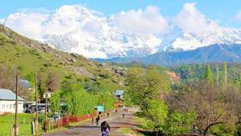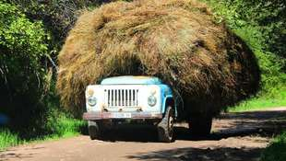

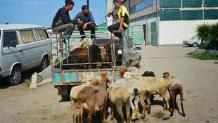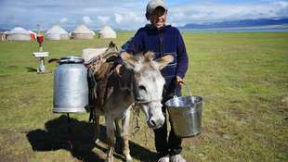

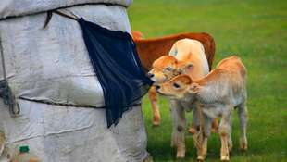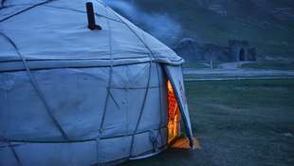

| **GROUP SIZE** | **PRICE IN USD/PER PERSON** |
| --- | --- |
| 2 | 2 510 USD |
| 3-4 | 2 045 USD |
| 5-6 | 1 630 USD |
| 7-8 | 1 450 USD |
| Supplementary for single accommodation | 175 USD |

| **PRICE INCLUDES** |  |
| --- | --- |
| Twin based accommodation | Bishkek - 3* hotel (2 o/n) Chon-Kemin - homestay (1 o/n) Jeti-Oguz - yurt camp (1 o/n) Kochkor - guesthouse (1 o/n) Song-Kul - yurt camp (2 o/n) Tash-Rabat - yurt camp (1 o/n) Naryn - guesthouse (1 o/n) Kazarman - homestay (1 o/n) Osh - guesthouse (2 o/n) Arslanbob - homestay (1 o/n) Toktogul - homestay (1 on) |
| *Side Note:* | *Accommodation conditions at yurt camp are very traditional,  meaning that person will be able to share toilet outside of the yurt and be able to experience Kyrgyz rural lifestyle firsthand.  Usually 3-6 pax per yurt (during the high season) Toilet and shower with warm water are in the corridor for general use. Single accommodation can be arranged if there is some vacant space.  Standard accommodation for 3-6 people per room* |
| Transport | Land transportation by air-conditioned non-smoking vehicle |
| Local guide services (Eng/Russ) | Included |
| Meals | Meals mentioned in the program |
| Entrance fees & excursions | Included |
| Felt craft show in Tamchy village | Included |
| Water | 1 liter person/day |

| **PRICE EXCLUDES** |  |
| --- | --- |
| International flights | Not included |
| Visa/letter of invitation to Kyrgyzstan | Not included |
| Personal expenses | Not included |
| Early check-in, late/check-out on arrival/departure days | Not included but could be arranged upon request for additional fee |
| Meals other than stated/beverages with meals | Not included |
| Tips to guide/driver (optional) | Not included |

**Contact information:**

[www.travelscruiser.com](http://www.travelscruiser.com)

Phone (24/7): +996 …………., +996 ……….

E-mail: [info@travelscruiser.com](mailto:info@travelscruiser.com)